Fitness Club Handling system

**Software Requirements Specification**

Version 1.0



**Group Id: F210272FD6 (BC180406440)**

**Supervisor Name : Aysha Zahid**

**Revision History**

|  |  |  |  |
| --- | --- | --- | --- |
| **Date (dd/mm/yyyy)** | **Version** | **Description** | **Author** |
| 2/jan/2022 | 1.0 | In this project we are developing the web application which will overcome these difficulties which people has to face when getting admission in health club. We are developing the “Fitness Club Handling System” which will handle the automate gym and fitness admission process. As we know admission process is difficult on their desired time and selecting a trainer is also difficult in the physical local club.  This Fitness Club System will provide the online admission process which make it easy for the user to get admission and view the club packages, book the desired slot, online payments, search the best trainer, view club packages and booked the desired slot, hire a trainer and get the diet chart and mark attendance everything is online through this platform of the fitness club. | **BC180406440** |
|  |  |  |  |
|  |  |  |  |
|  |  |  |  |

**Table of Contents**

1. Scope (of the project)
2. Functional Requirements Non Functional requirements
3. Use Case Diagram
4. Usage Scenarios
5. Adopted Methodology
6. Work Plan (Use MS Project to create Schedule/Work Plan)

**SRS Document**

**Scope of Project:**

**Introduction:**

In this modern era of technology a large number people of Pakistan use internet. People spend more time on social media platforms and many people post in urdu language. Many people only know urdu and they also type in urdu.

As we know Urdu is mother tongue of Pakistan and this web application will help and provide a flexible & easy platform to users to post their questions in urdu language, and the other users of application will answer the posted questions in urdu. The guest user can see the questions and their answers, and also find his/her question & answer. This type of application will promote Urdu language in Pakistan and will tend people to use & comminacte with others in urdu.

This web application will provide:

* Registered user can post question in urdu
* Registered user can answer the posted question in urdu.
* Registered user can mark answer as correct the already posted answer.
* Guest user can see posted questions & answers on application and also search questions and their answers.

**Purpose:**

The purpose of the website is to provide an online platform to post their question in Urdu language as Urdu is a mother tongue of Pakistani and people found it easy to read and write in Urdu language in websites. This website provides an online website people can post their question and can get the answers of their question in Urdu language. This platform makes it easy for the people to enter Urdu content in the website. It provides an easy and secure way of registration so the users can easy it easily. The user can easily get the answers of their question.

**Scope:**

This system has a scope because it can be used in market place for the people who can post the question in Urdu language.it has a scope because it provides a Urdu platform so the Urdu language user can found it more attractive and interesting to use.

**Functional and non Functional Requirements:**

**Functional Requirements:**

There will be three type of users:

* Admin
* Registered User
* Guest User (Unregistered user)

**Admin:**

Admin will able to edit or delete question/answer and also user. Admin should set the number of English words are allowed to use while posting question/answer.

**Registered User:**

Registered user can see & post questions and answer the posted questions.

**Guest User (Unregistered user):**

Guest user only can use posted questions/answers and search questions/answers according to need.

**Modules:**

**Registered User Module:**

1. **User Registration and Sign In:** There will be a registration form where user can register by providing information. A registered user will able to login into application by enetering credentials.
2. **View and Search Questions/Answers:** The registered user can see posted questions/answers and also search questions.
3. **Post Question:** The registered user can post question in urdu with limited amount of English words.
4. **Post Answer:** The registered user can post the answer of posted question of other user in urdu with limited amount of English words.**The registered user can only post answer of other user and not able to post answer of own question**.
5. **Edit and Delete Question:** The registered user can edit and delete his/her posted question and answer.
6. **Correct the Answer:** The registered user can mark answer as correct the posted answer and make it more helpful for others.
7. **Manage Profile:** The registered user can manage his/her profile.

**Admin Module:**

1. **Login:** Admin can login into site by entering valid credentials to access and manage site.
2. **Manage Users:** Admin can edit and delete user.
3. **Edit and Delete Questions/Answers:** Admin can edit any question/answer and also can delete any question/answer.
4. **Set Limit:** Admin can set the limit for use of English words.

**Guest User Module:**

1. **See Question/Answer:** The guest user can the see homepage where he/she can see the posted question/answer.
2. **Search Questions:** The guest user can search question according to need and will find answer according to question.

**Order of content:**

The order of posted questions/answers should be display in date-posted order.

**Search & Search Result:**

The search have filters and search result will display title of question, preview text etc.

**Non-Functional Requirements:**

This application will have following non-functional requirements:

* **User Interface:** Homepage of site will be eye catching and simple so every type of user will easily use application.
* **Performance:** The performance of site should be good and especially while searching the result the speed should be good.
* **Capability & Availabilty:** The site should be able to manage multiple and large number of users and should be available for users everytime.
* **Maintainance:** Site should easily maintainable.

**Use Case Diagram(s):**

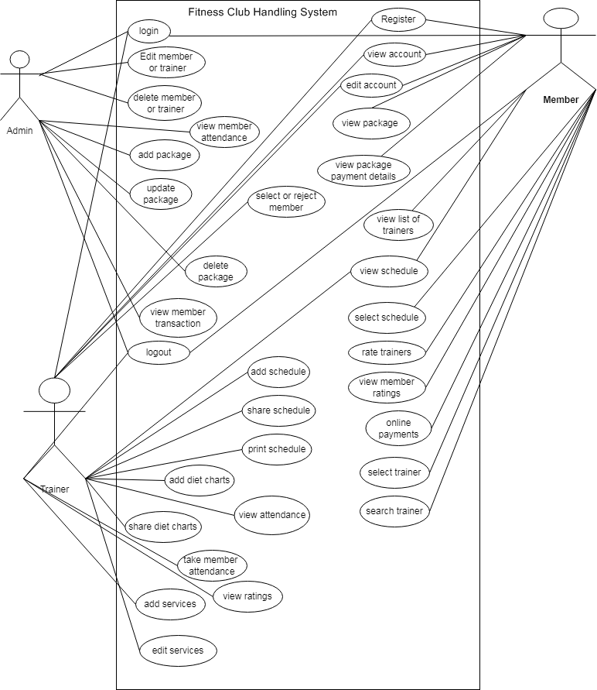

**Usage Scenarios:**

**Usage scenarios 1:**

|  |  |  |  |
| --- | --- | --- | --- |
| Use case title | Register | | |
| Abbreviated title |  | | |
| Use case ID | 1 | | |
| Actors | Member/trainer | | |
| Description | In this use case the user can register in the website application by selection the register option. | | |
| Pre-conditions | Internet connection should be available and user open the website. | | |
| Task sequence | | | Exceptions |
| 1. The user must open the website  2. The user must select the register option to register himself in the website and the user account will be created. | | | 1. The system will create the user account and save the member account details in the database.  2. If any error comes up in registration process it informs the user. |
| Post condition | | user has successfully registered in the application and user account has been created. | |
| Author | | Bc180406440 | |

**Usage scenarios 2:**

|  |  |  |  |
| --- | --- | --- | --- |
| Use case title | login | | |
| Abbreviated title |  | | |
| Use case ID | 2 | | |
| Actors | Member/admin/trainer | | |
| Description | In this use case the user after registration can login in its account. | | |
| Pre-conditions | Internet connection should be available and user must register first in the website. | | |
| Task sequence | | | Exceptions |
| 1. The user must open the website  2. The usermust select the login option to login in its account. | | | 1. The system will search the user account if member account details exist in the database then the system let the user to login otherwise it shows the message to register first. |
| Post condition | | User has successfully login in its account. | |
| Author | | Bc180406440 | |

**Usage scenarios 3:**

|  |  |  |  |
| --- | --- | --- | --- |
| Use case title | View account | | |
| Abbreviated title |  | | |
| Use case ID | 3 | | |
| Actors | Member/trainer | | |
| Description | In this use case the user after login in the account can view its account. | | |
| Pre-conditions | the user must login in its account | | |
| Task sequence | | | Exceptions |
| 1. The user can view its account after login.  2. The member must select the view account option to view its account. | | | 1. The system will fetch all the account data of the member from database and show it in the user account only if the data exist. |
| Post condition | | User has successfully view its account. | |
| Author | | Bc180406440 | |

**Usage scenarios 4:**

|  |  |  |  |
| --- | --- | --- | --- |
| Use case title | Edit account | | |
| Abbreviated title |  | | |
| Use case ID | 4 | | |
| Actors | Member/trainer | | |
| Description | In this use case the user after login in the account can edit its account. | | |
| Pre-conditions | The user must login in its account | | |
| Task sequence | | | Exceptions |
| 1. The user can edit its account after login.  2. The user must select the edit account option to edit its account information. | | | 1. The system will save the new account information enter by member in the database. |
| Post condition | | User has successfully edit its account. | |
| Author | | Bc180406440 | |

**Usage scenarios 5:**

|  |  |  |  |
| --- | --- | --- | --- |
| Use case title | View Packages | | |
| Abbreviated title |  | | |
| Use case ID | 5 | | |
| Actors | Member | | |
| Description | In this use case the member can view all the fitness club packages. | | |
| Pre-conditions | the member must open the website | | |
| Task sequence | | | Exceptions |
| 1. The member can view all the packages information from the website. | | | 1. The system will fetch all the packages information from the database and show it in the website. |
| Post condition | | Member has successfully view the packages information. | |
| Author | | Bc180406440 | |

**Usage scenarios 6:**

|  |  |  |  |
| --- | --- | --- | --- |
| Use case title | View Packages payment details | | |
| Abbreviated title |  | | |
| Use case ID | 6 | | |
| Actors | Member | | |
| Description | In this use case the member can view all the fitness club packages and their payment details. | | |
| Pre-conditions | the member must open the website | | |
| Task sequence | | | Exceptions |
| 1. The member can view all the packages information from the website with payment details. | | | 1. The system will fetch all the packages information with payment information from the database and show it in the website. |
| Post condition | | Member has successfully view the packages information with payment details. | |
| Author | | Bc180406440 | |

**Usage scenarios 7:**

|  |  |  |  |
| --- | --- | --- | --- |
| Use case title | View list of trainers | | |
| Abbreviated title |  | | |
| Use case ID | 7 | | |
| Actors | Member | | |
| Description | In this use case the member can view all the fitness club tainers | | |
| Pre-conditions | the member must open the website and select the view trainers option | | |
| Task sequence | | | Exceptions |
| The member can view the entire trainers list by selecting the view trainer option. | | | The system will fetch all the trainers’ information from the database and show it in the website. |
| Post condition | | Member has successfully view list of the trainers. | |
| Author | | Bc180406440 | |

**Usage scenarios 8:**

|  |  |  |  |
| --- | --- | --- | --- |
| Use case title | View schedule | | |
| Abbreviated title |  | | |
| Use case ID | 8 | | |
| Actors | Member | | |
| Description | In this use case the member can view the entire available schedule list. | | |
| Pre-conditions | the member must open the website and select the view schedule option | | |
| Task sequence | | | Exceptions |
| The member can view the entire schedule list by selecting the view schedule option. | | | The system will fetch all the available schedule information from the database and show it in the website. |
| Post condition | | Member has successfully view schedule. | |
| Author | | Bc180406440 | |

**Usage scenarios 9:**

|  |  |  |  |
| --- | --- | --- | --- |
| Use case title | Select schedule | | |
| Abbreviated title |  | | |
| Use case ID | 9 | | |
| Actors | Member | | |
| Description | In this use case the member can select the schedule from the list. | | |
| Pre-conditions | the member must open the website and select the select schedule option | | |
| Task sequence | | | Exceptions |
| The member can select the schedule from the list by selecting the select schedule option. | | | The system will save the login user select schedule in the database. |
| Post condition | | Member has successfully view schedule. | |
| Author | | Bc180406440 | |

**Usage scenarios 10:**

|  |  |  |  |
| --- | --- | --- | --- |
| Use case title | Rate trainers | | |
| Abbreviated title |  | | |
| Use case ID | 10 | | |
| Actors | Member | | |
| Description | In this use case the member can rate the trainer | | |
| Pre-conditions | the member must open the website and login in its account and select the option rate trainers. | | |
| Task sequence | | | Exceptions |
| The member can rate the trainer by selecting the rate trainer option. | | | The system will save the user rating of the trainer in the database. |
| Post condition | | Member has successfully rate the trainer. | |
| Author | | Bc180406440 | |

**Usage scenarios 11:**

|  |  |  |  |
| --- | --- | --- | --- |
| Use case title | View member rating | | |
| Abbreviated title |  | | |
| Use case ID | 11 | | |
| Actors | Member | | |
| Description | In this use case the member can view the other member rating | | |
| Pre-conditions | the member must open the website and select the option view member rating of the trainer. | | |
| Task sequence | | | Exceptions |
| The member can view all the rating of the trainer by selecting the view member rating option. | | | The system will fetch all the member rating of the trainer from the database and show it. |
| Post condition | | Member has successfully view the member rating about the trainer. | |
| Author | | Bc180406440 | |

**Usage scenarios 12:**

|  |  |  |  |
| --- | --- | --- | --- |
| Use case title | Online payments | | |
| Abbreviated title |  | | |
| Use case ID | 12 | | |
| Actors | Member | | |
| Description | In this use case the member can pay the amount online after selecting the package and schedule and each and everything. | | |
| Pre-conditions | The member must open the website and must login in its account and member can do the online payment by selecting the online payment option. | | |
| Task sequence | | | Exceptions |
| The member can do the online payment of its package by selecting the online payment option. | | | The system will save the user online payment details in the database. |
| Post condition | | Member has successfully do the online payment. | |
| Author | | Bc180406440 | |

**Usage scenarios 13:**

|  |  |  |  |
| --- | --- | --- | --- |
| Use case title | Search trainers | | |
| Abbreviated title |  | | |
| Use case ID | 13 | | |
| Actors | Member | | |
| Description | In this use case the can search the trainers | | |
| Pre-conditions | The member must open the website and member can search trainer by selecting the search trainer option. | | |
| Task sequence | | | Exceptions |
| The member can search the trainer by name by clicking search trainer option. | | | The system will fetch all the data related to search of the member from the database. |
| Post condition | | Member has successfully search the trainers. | |
| Author | | Bc180406440 | |

**Usage scenarios 14:**

|  |  |  |  |
| --- | --- | --- | --- |
| Use case title | Select trainer | | |
| Abbreviated title |  | | |
| Use case ID | 14 | | |
| Actors | Member | | |
| Description | In this use case the can select any of the trainer of its choice from the list and hire it. | | |
| Pre-conditions | The member must open the website and must login in its account member can select and hire the trainer by selecting the select trainer option. | | |
| Task sequence | | | Exceptions |
| The member can select the trainer of its choice by clicking select trainer option. | | | The system will save the user select trainer in the database. |
| Post condition | | Member has successfully select the trainers. | |
| Author | | Bc180406440 | |

**Usage scenarios 15:**

|  |  |  |  |
| --- | --- | --- | --- |
| Use case title | logout | | |
| Abbreviated title |  | | |
| Use case ID | 15 | | |
| Actors | Member/admin/trainer | | |
| Description | in this use case the user can logout from its account by selecting logout option. | | |
| Pre-conditions | The user must open the website and must login in its account and select logout option | | |
| Task sequence | | | Exceptions |
| user can logout from its account by selecting logout option. | | | the app will logout the admin from its account. |
| Post condition | | The user successfully logout from its account. | |
| Author | | Bc180406440 | |

**Usage scenarios 16:**

|  |  |  |  |
| --- | --- | --- | --- |
| Use case title | Select or reject member | | |
| Abbreviated title |  | | |
| Use case ID | 16 | | |
| Actors | trainer | | |
| Description | In this use case the trainer can select or reject the user hire or select request. | | |
| Pre-conditions | The trainer must login in its account and select the view hire request option | | |
| Task sequence | | | Exceptions |
| Trainer can view all the member hire or select request the trainer can response to the request trainer can select or reject it. | | | 1. The system will save the response of the trainer of user request in the database. |
| Post condition | | Trainer has successfully select or reject the member. | |
| Author | | Bc180406440 | |

**Usage scenarios 17:**

|  |  |  |  |
| --- | --- | --- | --- |
| Use case title | Add schedule | | |
| Abbreviated title |  | | |
| Use case ID | 17 | | |
| Actors | trainer | | |
| Description | In this use case the trainer can add its schedule. | | |
| Pre-conditions | The trainer must login in its account and select the add schedule option | | |
| Task sequence | | | Exceptions |
| Trainer can add his schedule by selecting the add schedule option. | | | 1. The system will save the schedule details in the database. |
| Post condition | | Trainer has successfully add the schedule. | |
| Author | | Bc180406440 | |

**Usage scenarios 18:**

|  |  |  |  |
| --- | --- | --- | --- |
| Use case title | Share schedule | | |
| Abbreviated title |  | | |
| Use case ID | 18 | | |
| Actors | trainer | | |
| Description | In this use case the trainer can share the schedule. | | |
| Pre-conditions | The trainer must login in its account and select the share schedule option | | |
| Task sequence | | | Exceptions |
| Trainer can share his schedule by selecting the share schedule option. | | | 1. The system will share the selected schedule details. |
| Post condition | | Trainer has successfully share the schedule. | |
| Author | | Bc180406440 | |

**Usage scenarios 19:**

|  |  |  |  |
| --- | --- | --- | --- |
| Use case title | Print schedule | | |
| Abbreviated title |  | | |
| Use case ID | 19 | | |
| Actors | trainer | | |
| Description | In this use case the trainer can print the schedule. | | |
| Pre-conditions | The trainer must login in its account and select the print schedule option | | |
| Task sequence | | | Exceptions |
| Trainer can print his schedule by selecting the print schedule option. | | | 1. The system will print the selected schedule details. |
| Post condition | | Trainer has successfully print the schedule. | |
| Author | | Bc180406440 | |

**Usage scenarios 20:**

|  |  |  |  |
| --- | --- | --- | --- |
| Use case title | Add diet chart | | |
| Abbreviated title |  | | |
| Use case ID | 20 | | |
| Actors | trainer | | |
| Description | In this use case the trainer can add the diet chart for each individual member | | |
| Pre-conditions | The trainer must login in its account and select the add diet chart option | | |
| Task sequence | | | Exceptions |
| Trainer can add the diet chart of each individual member by selecting the add diet chart option. | | | The system will save the diet chart of each individual detail in the database. |
| Post condition | | Trainer has successfully add the diet chart of each individual member. | |
| Author | | Bc180406440 | |

**Usage scenarios 21:**

|  |  |  |  |
| --- | --- | --- | --- |
| Use case title | share diet chart | | |
| Abbreviated title |  | | |
| Use case ID | 21 | | |
| Actors | trainer | | |
| Description | In this use case the trainer can share the diet chart to each individual member | | |
| Pre-conditions | The trainer must login in its account and select the share diet chart option | | |
| Task sequence | | | Exceptions |
| Trainer can share the diet chart of each individual member to member by selecting the add diet chart option. | | | The system will share the diet chart details to member saved in the database. |
| Post condition | | Trainer has successfully share the diet chart of each individual member. | |
| Author | | Bc180406440 | |

**Usage scenarios 22:**

|  |  |  |  |
| --- | --- | --- | --- |
| Use case title | Take member attendance | | |
| Abbreviated title |  | | |
| Use case ID | 22 | | |
| Actors | trainer | | |
| Description | In this use case the trainer can take attendance of each individual member | | |
| Pre-conditions | The trainer must login in its account and select the take member attendance option | | |
| Task sequence | | | Exceptions |
| Trainer can take the attendance of the member by selecting the take member attendance option. | | | The system will save the attendance detail of member in the database. |
| Post condition | | Trainer has successfully take the member attendance. | |
| Author | | Bc180406440 | |

**Usage scenarios 23:**

|  |  |  |  |
| --- | --- | --- | --- |
| Use case title | View attendance | | |
| Abbreviated title |  | | |
| Use case ID | 23 | | |
| Actors | Trainer/admin | | |
| Description | In this use case the actor can view the attendance of each individual member | | |
| Pre-conditions | The actor must login in its account and select the view attendance option | | |
| Task sequence | | | Exceptions |
| Actor can view the attendance of the member by selecting view attendance option. | | | The system will fetch all the member attendance details from the database and show it. |
| Post condition | | Actor has successfully view the member attendance. | |
| Author | | Bc180406440 | |

**Usage scenarios 24:**

|  |  |  |  |
| --- | --- | --- | --- |
| Use case title | View rating | | |
| Abbreviated title |  | | |
| Use case ID | 24 | | |
| Actors | trainer | | |
| Description | In this use case the trainer can view his rating which member has given to it | | |
| Pre-conditions | The trainer must login in its account and select the view rating option | | |
| Task sequence | | | Exceptions |
| Trainer can view his rating by selecting view rating option given by member. | | | The system will fetch all the rating of the trainer details from the database and show it. |
| Post condition | | Trainer has successfully view the ratings. | |
| Author | | Bc180406440 | |

**Usage scenarios 25:**

|  |  |  |  |
| --- | --- | --- | --- |
| Use case title | Add services | | |
| Abbreviated title |  | | |
| Use case ID | 25 | | |
| Actors | trainer | | |
| Description | In this use case the trainer can add his services | | |
| Pre-conditions | The trainer must login in its account and select the add services option | | |
| Task sequence | | | Exceptions |
| Trainer can add his services by selecting add services option. | | | The system will save all the services detail in the database. |
| Post condition | | Trainer has successfully add his services. | |
| Author | | Bc180406440 | |

**Usage scenarios 26:**

|  |  |  |  |
| --- | --- | --- | --- |
| Use case title | Edit services | | |
| Abbreviated title |  | | |
| Use case ID | 26 | | |
| Actors | trainer | | |
| Description | In this use case the trainer can edit his services | | |
| Pre-conditions | The trainer must login in its account and select the edit services option | | |
| Task sequence | | | Exceptions |
| Trainer can edit his services by selecting edit services option. | | | The system will save all the new edited services detail in the database. |
| Post condition | | Trainer has successfully edit his services. | |
| Author | | Bc180406440 | |

**Usage scenarios 27:**

|  |  |  |  |
| --- | --- | --- | --- |
| Use case title | Edit member or trainer | | |
| Abbreviated title |  | | |
| Use case ID | 27 | | |
| Actors | admin | | |
| Description | In this use case the admin can edit the details of the member or trainer | | |
| Pre-conditions | The admin must login in its account and select the selected member or trainer for editing by selecting edit button | | |
| Task sequence | | | Exceptions |
| Admin can edit the details of selected member or trainer by selecting the edit option. | | | The system will save all the new edited detail in the database. |
| Post condition | | Admin has successfully edit the trainer or member. | |
| Author | | Bc180406440 | |

**Usage scenarios 28:**

|  |  |  |  |
| --- | --- | --- | --- |
| Use case title | Delete member or trainer | | |
| Abbreviated title |  | | |
| Use case ID | 28 | | |
| Actors | admin | | |
| Description | In this use case the admin can delete the account of member or trainer | | |
| Pre-conditions | The admin must login in its account and select the selected member or trainer for deleting by selecting delete button | | |
| Task sequence | | | Exceptions |
| Admin can delete selected member or trainer account by selecting the delete option. | | | The system will delete the member or trainer account from the database. |
| Post condition | | Admin has successfully delete the trainer or member. | |
| Author | | Bc180406440 | |

**Usage scenarios 29:**

|  |  |  |  |
| --- | --- | --- | --- |
| Use case title | Add package | | |
| Abbreviated title |  | | |
| Use case ID | 29 | | |
| Actors | admin | | |
| Description | In this use case the admin can add packages | | |
| Pre-conditions | The admin must login in its account and select the add package option | | |
| Task sequence | | | Exceptions |
| Admin can add the package by selecting add package option. | | | The system will save all the packages detail in the database. |
| Post condition | | Admin has successfully add the packages. | |
| Author | | Bc180406440 | |

**Usage scenarios 30:**

|  |  |  |  |
| --- | --- | --- | --- |
| Use case title | Update package | | |
| Abbreviated title |  | | |
| Use case ID | 30 | | |
| Actors | admin | | |
| Description | In this use case the admin can edit the package details | | |
| Pre-conditions | The admin must login in its account and select the update package option | | |
| Task sequence | | | Exceptions |
| Admin can edit the package detail by selecting edit package option. | | | The system will save all the new edited package detail in the database. |
| Post condition | | Trainer has successfully edit the packages. | |
| Author | | Bc180406440 | |

**Usage scenarios 31:**

|  |  |  |  |
| --- | --- | --- | --- |
| Use case title | Delete package | | |
| Abbreviated title |  | | |
| Use case ID | 31 | | |
| Actors | admin | | |
| Description | In this use case the admin can delete any package | | |
| Pre-conditions | The admin must login in its account and select the selected package for deleting by selecting delete button | | |
| Task sequence | | | Exceptions |
| Admin can delete selected package by selecting the delete option. | | | The system will delete the package from the database. |
| Post condition | | Admin has successfully delete the package. | |
| Author | | Bc180406440 | |

**Usage scenarios 32:**

|  |  |  |  |
| --- | --- | --- | --- |
| Use case title | View member transaction | | |
| Abbreviated title |  | | |
| Use case ID | 32 | | |
| Actors | admin | | |
| Description | In this use case the admin can view all the details of member online payment transaction. | | |
| Pre-conditions | The admin must login in its account and select view member transaction button. | | |
| Task sequence | | | Exceptions |
| Admin can view the online transaction detail of any member . | | | The system will fetch the selected member online transaction details from the database and show it. |
| Post condition | | Admin has successfully view member transaction. | |
| Author | | Bc180406440 | |

**Adopted Methodology**

Introduction:

Project planning is a discipline for stating how to complete a project within a certain timeframe, usually with defined stages, and with designated resources.

Methodology:

A methodology is a model, which is used for the design, planning, implementation and achievement of their project objectives. There are different methodologies to benefit different projects.

**Available Methodology:**



**The waterfall model:**

The waterfall model is a sequential design process, used in software development processes, in which progress is seen as flowing steadily downwards (like a waterfall) through the phases of Conception, Initiation, Analysis, Design, Construction, Testing, Production/Implementation and Maintenance.

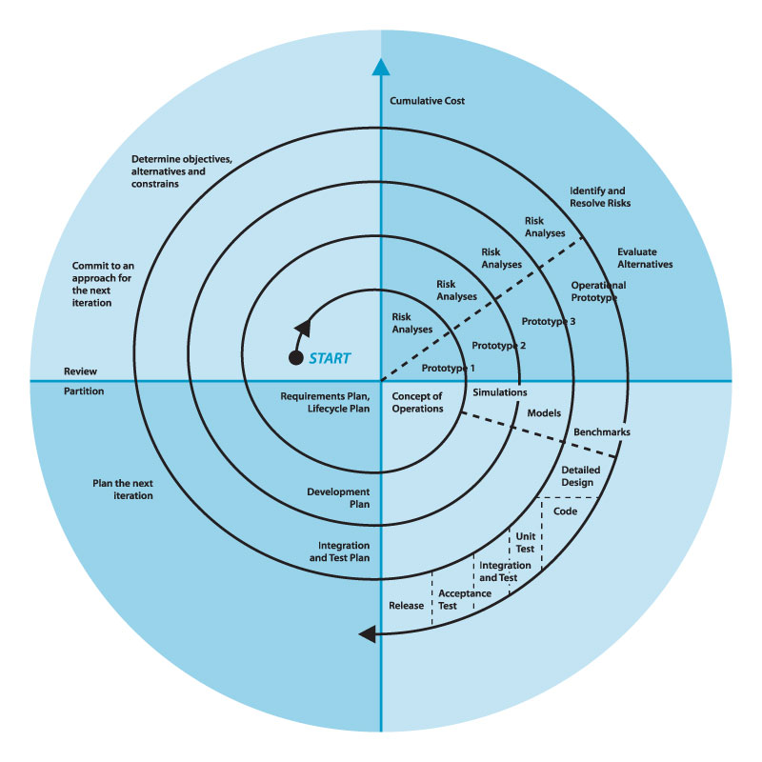

**The spiral model:**

The spiral model, also known as the spiral lifecycle model, is a systems development method (SDM) used in information technology (IT). This model of development combines the features of the prototyping model and the systems development life cycle (SDLC).

**Chosen Methodology:**

It is a method used for development of project. I have adopted the VU Process Model which is the combination of Waterfall methodology and Spiral methodology. VU Process Model will combine the benefits of Waterfall and Spiral methodologies.

**Reasons for chosen Methodology:**

The main idea to choose is to get the benefits of both these models.

* It is sequential model with backward repetition.
* In vu process model we will be work in phases to complete the given project.
* All the activities are performed in a sequence in VU Process Model.
* Maximize the quality of system and minimize the disadvantages and risk.
* System is more responsive to user requirements.
* Cost and schedule are more accurate.
* It is good to use vu process model which gives the nature of both methodology to complete the project successfully.

**Work Plan (Use MS Project to create Schedule/Work Plan)**

